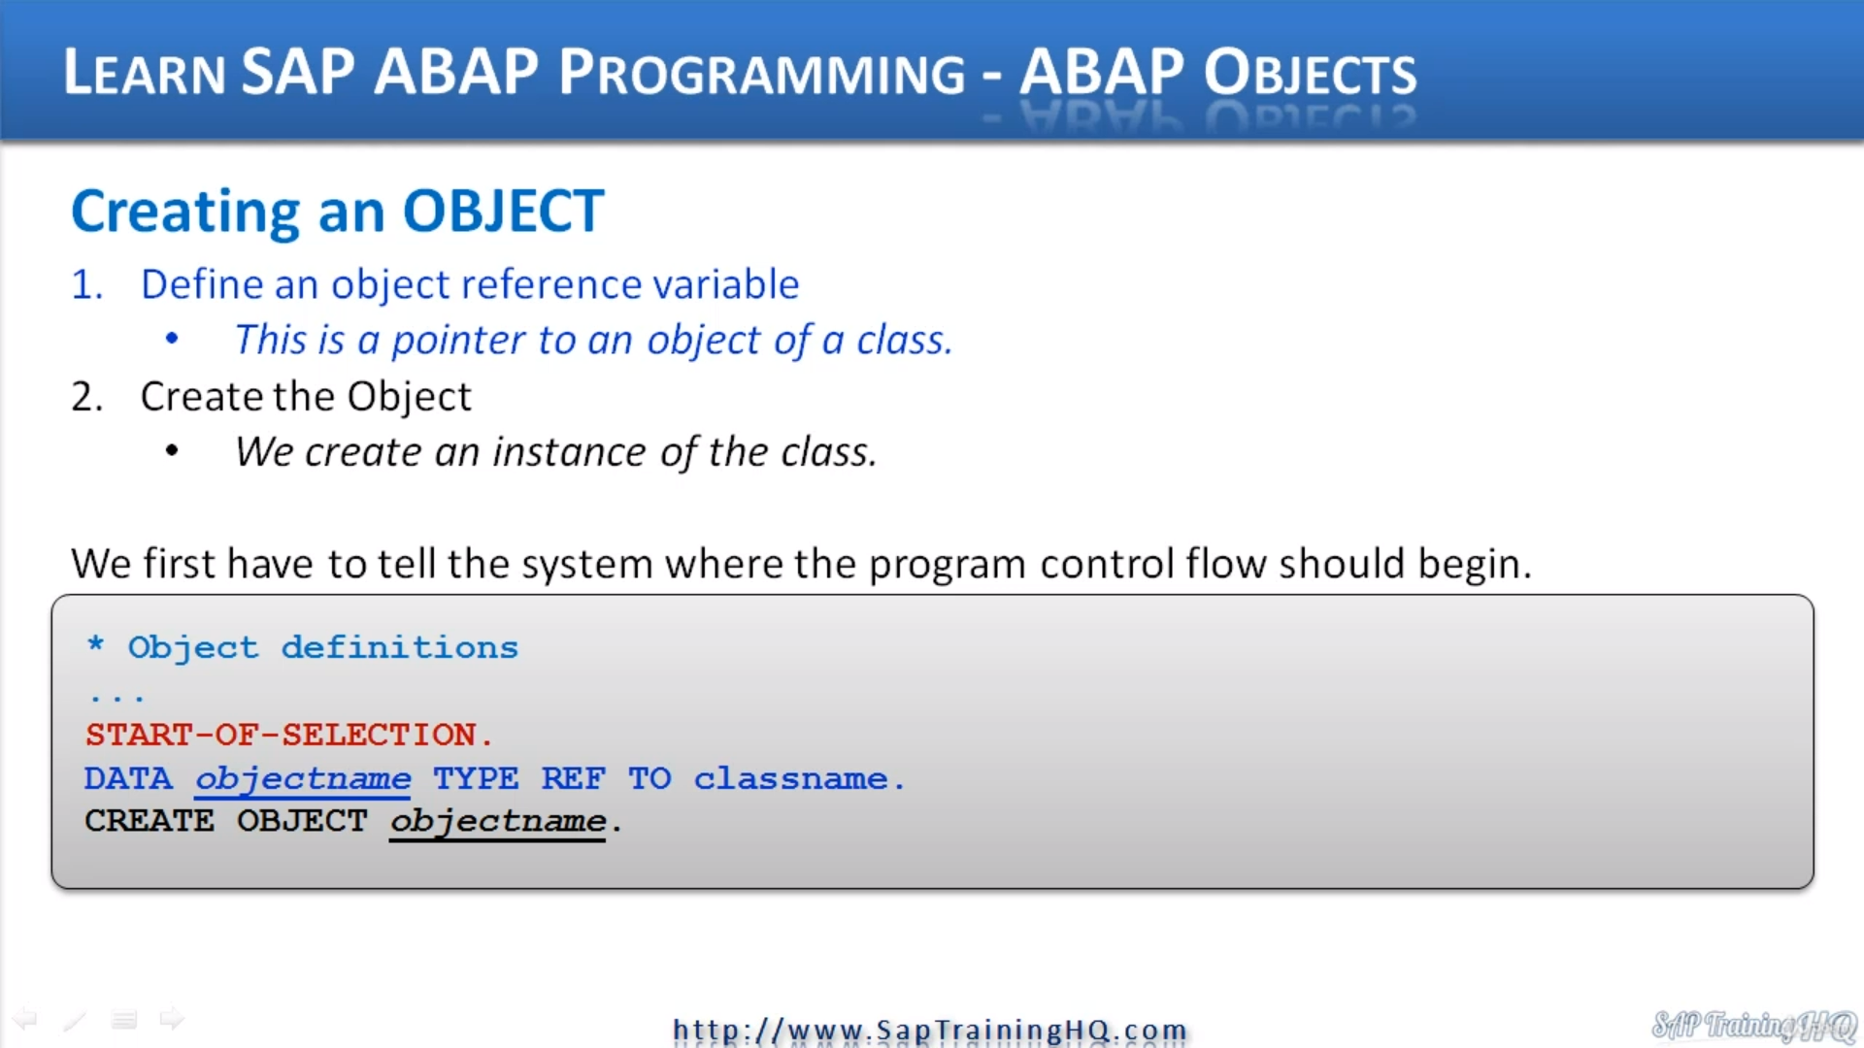

In this video, we're going to look at creating objects now.

So, we have already defined a class, and if we compare what we have done to a procedural about programming point of view, well, what we've done is the equivalent of declaring a type statement.

Doesn't sound like much, does it?

But now in reality, I guess what we have done, we've created the equivalent of a form or a function module.

We put the framework in place to use encapsulated code from within our local programs.

What we need to do now is look and learn how we create objects based on the class.

So, the first thing we need to do, as you can see on the slide, it's a two-step process.

The first thing is we need to define an object reference variable.

Now sounds a bit grand, doesn't it, but all this is, is we're declaring a variable that is just a pointer to an object of a specific class.

Once we have defined this pointer, this object reference variable, we can then create our object and when we speak in object-oriented terms, we create an instance of our object.

And then what I'm going to do, like with any normal program, we must tell the system where we want it to stop processing our code.

So, I'm sure everyone is familiar with start of selection, if you're not, this is what we used to tell the system.

This is where we want to start processing our code from in our program. So, what we're going to do is start of selection. And then we need to declare a data statement because we used a data statement to declare our object reference variable, so we have data.

And then what we do, we give it a name, so I'm going to say just simply car1. So, I'm going to create an object reference variable called car1, and then we use type, but it's a specific one we use type reference to and then we specify the class name.

START-OF-SELECTION.             "We need to tell the system where to start our program.  
  
  DATA car1 TYPE REF TO car.    "Define an object reference variable. Notice how we have to use TYPE REF TO  
  CREATE OBJECT car1.

OK, so Data CaR1 time reference to a car, then we must create the object itself.

So, what we've done is create a datA of variable that's going to hold an object reference.

OK, we haven't created the object yet.

So, the second step to create the object.

is create object, and then we specify our object reference variable, our car1 and that's it.

We have now created an instance of our car class.

All we're doing is instantiating an object called CAR1 and not nothing more.

We haven't called any of the methods within our class to increase the speed, slowing down, set the number of seats and so on.

We've just created a basic object. Now, before we go on and use some of these methods.